网络空间安全导论lecture 1

任奎

Introduction to Cybersecurity：A Critical Challenge to the Society

Cpberspace（赛博/网络空间）

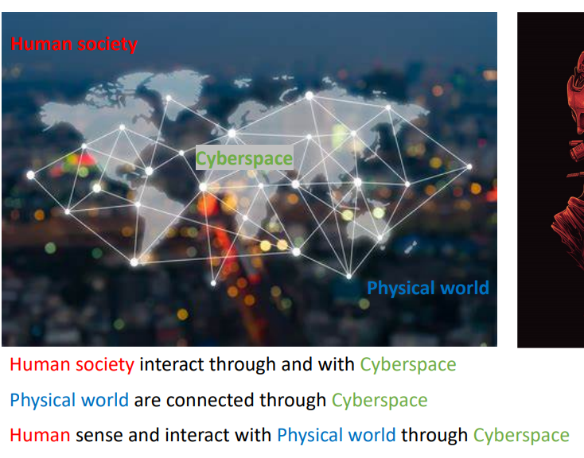

“Security” starts with Cryptography.

Cryptography has a deep root in War and Politics.

凯撒密码

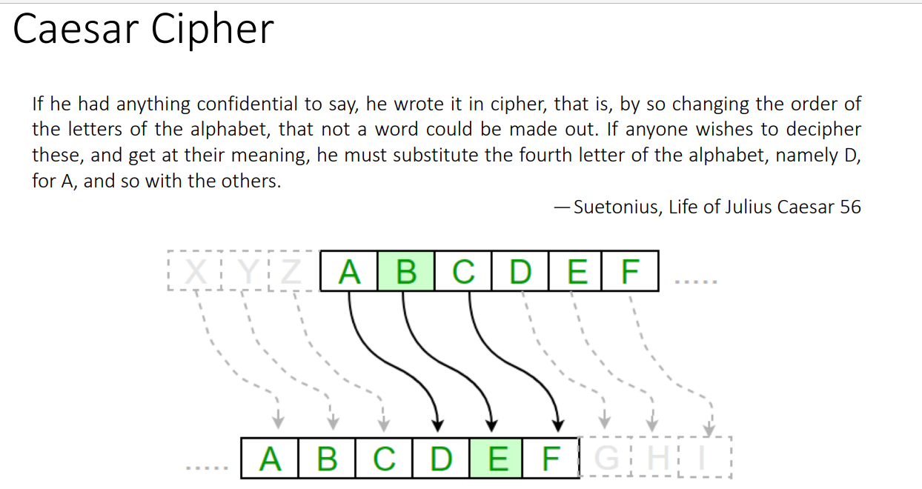

World war ||：electricity出现了，有了radio communication，但是是open in the air，敌人也能收到，所以要加密

German blitzkrieg（闪电战）

Enigmas machine：加密机器

Turing and the Bombe Machine

加速二战结束

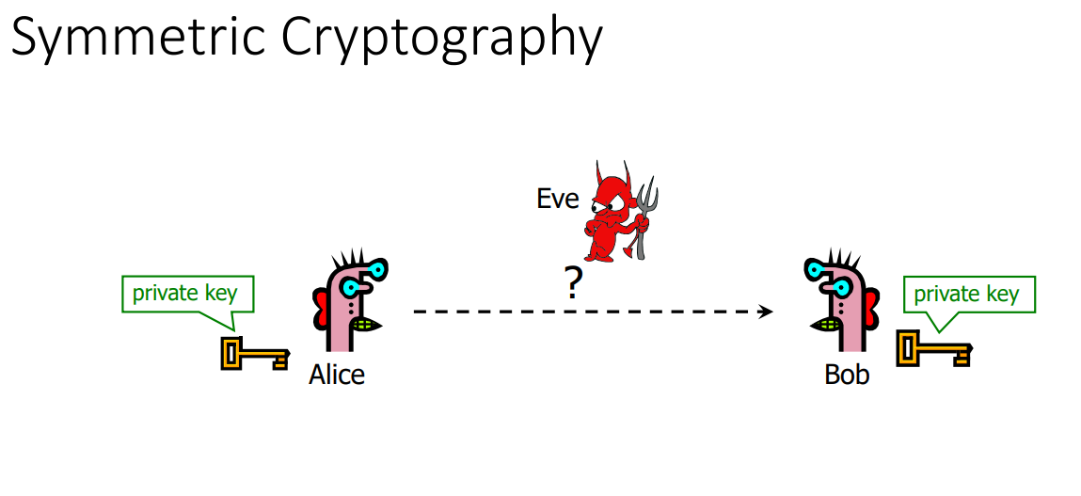

对称加密

加密的两个人叫alice和bob

坏人是eve

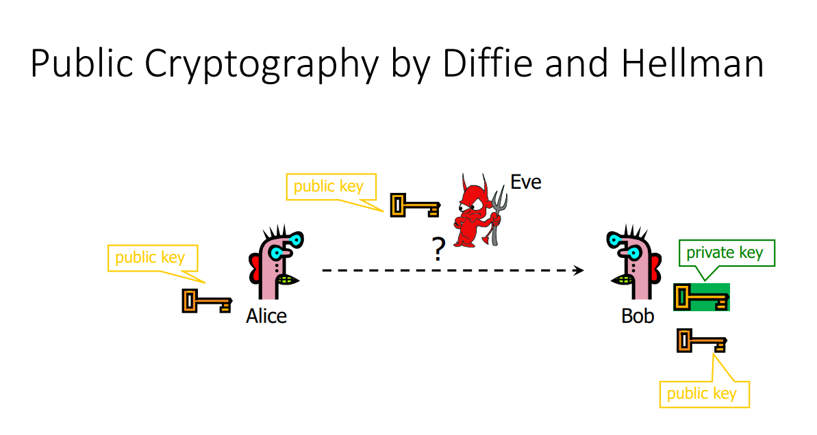

Diffie and Hellman发明的加密

把public key 公开，所有有public key的人都可以给他发

RSA算法

Private key——>电子签名（认证）——>怎么证明你是你

With the born of Internet, security went far beyond cryptographyand becomes what we call today “Cyber Security”!

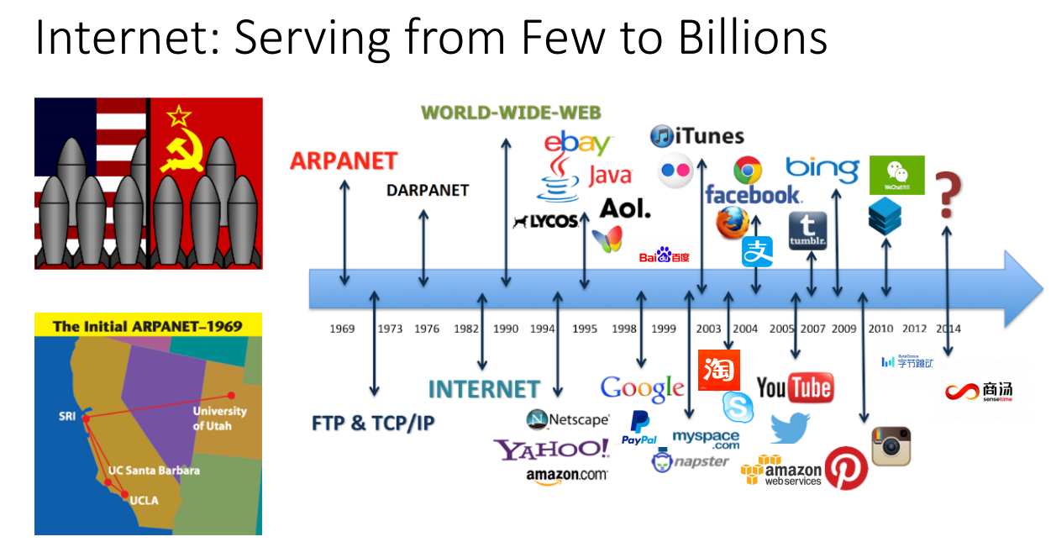

从计算机诞生之际，安全一直伴随着我们

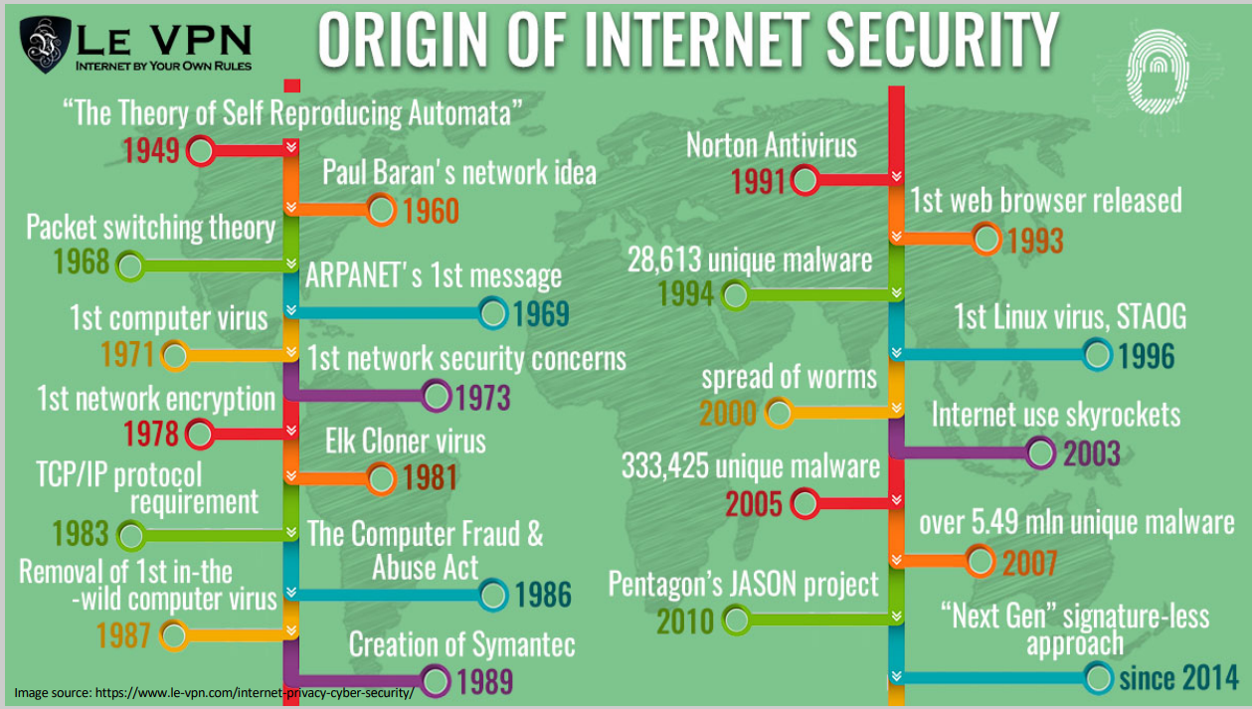

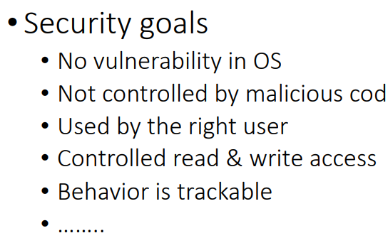

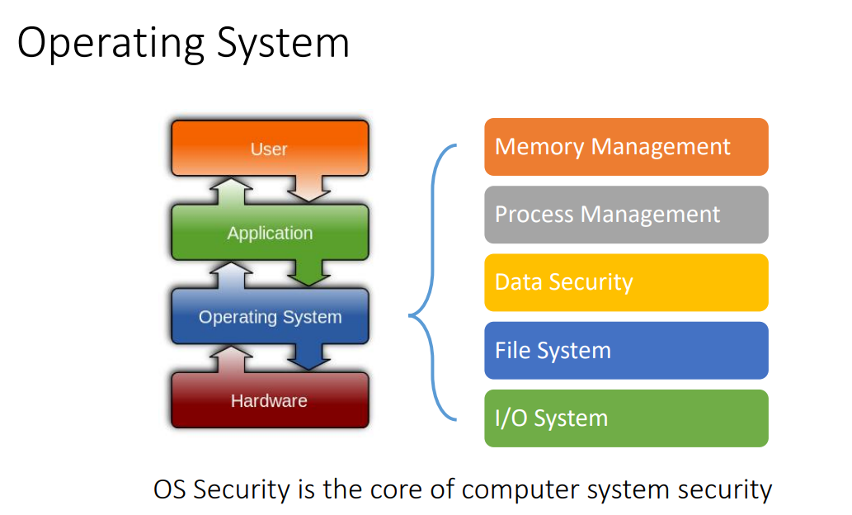

·Computer virus

·Software Vulnerabilities

·Sources

•Bugs in the application

•Inappropriate features in the infrastructure

•Main causes

•Complexity of software features: functionality winning over security

•Ignorance of developers

·APPSecurity

·Cloud Computing Security

·InternetofThings Security

·IoT Security(物联网) 更多的与人相关

大数据对人的control

AI 有益有害

病毒：

Stuxnet (2010): the world’s 1st virus written for industrial control systems

Heartbleed Bug (2014)

WannaCry Ransomware Attack (2017)

The Facebook Data Breaches (201?)

DDoS Attacks: GitHub (2018) and Mirai(2017)

The Vulnerability of Amazon Echo Dot (2017)

DeepFakeVideos about Obama (2018)

Government Operations after WWII

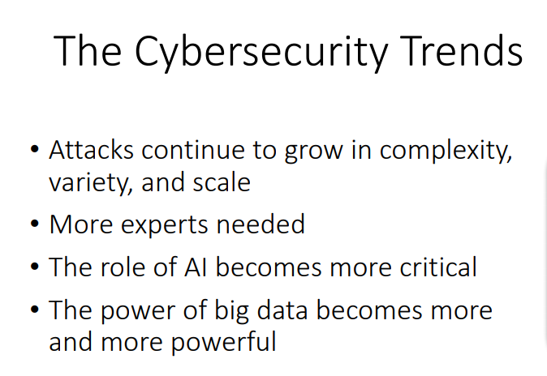

——>More on Law & Regulations

CourseEvaluation

1. Class Attendance ——10%

(2)Homework——10%

(3) Project、Final Exam ——80%